SMART TRAFFIC SIGNAL OPTIMIZATION

SAKTHI I G

192371038

CSA0959

PROGRAMMING IN JAVA FOR SCIENTIFIC APPLICATIONS

Question:

You are part of a team working on an initiative to optimize traffic signal management in a busy city to reduce congestion and improve traffic flow efficiency using smart technologies.

**1.Data Collection and Modeling:**

To collect and manage real-time traffic data from sensors, we'll define data structures that can store this information efficiently. We'll have two main entities: Traffic Sensor Data and Intersection.

**Traffic Sensor Data:**

This class will represent the data collected from traffic sensors at various intersections.

**Attributes:**

* **Sensor ID:** Unique identifier for the sensor**.**
* **Intersection ID**: Foreign key linking to the intersection where the sensor is located.
* **Timestamp:** The time at which the data is collected.
* **Vehicle Count:** Number of vehicles detected by the sensor.
* **Average Speed:** Average speed of the vehicles detected.
* **Traffic Density**: Calculated density of the traffic (vehicles per unit area).
* **Queue Length**: Length of the vehicle queue at the intersection.
* **Pedestrian Crossing Count:** Number of pedestrians waiting to cross.

public class TrafficSensorData

{

private String sensorID;

private String intersectionID;

private long timestamp;

private int vehicleCount;

private double averageSpeed;

private double trafficDensity;

private int queueLength;

private int pedestrianCrossingCount;

}

**2. Algorithm Design:**

Optimization Algorithm:

The core of the system is the algorithm that analyzes the collected data and adjusts the signal timings to optimize traffic flow. The algorithm considers various factors such as:

Traffic Density: High traffic density might indicate the need for longer green lights.

Queue Length: Long vehicle queues might require an extension of green lights to clear the congestion.

Pedestrian Crossings: If there are many pedestrians waiting, the system should prioritize pedestrian signals to ensure safety.

**3. Implementation:**

Real-time Integration:

The implementation involves integrating with traffic sensors to collect data and adjusting traffic signal timings in real-time. This requires:

TrafficSensorData and Intersection classes to model the data.

TrafficSignalOptimizer class to implement the optimization algorithm.

TrafficSignalController manages the intersections and periodically updates the signal timings based on the collected data.

**4. Visualization and Reporting:**

Data Flow Diagram: A diagram illustrating how data flows from sensors to the optimization algorithm and then to the traffic signal controllers helps in understanding the overall system architecture.

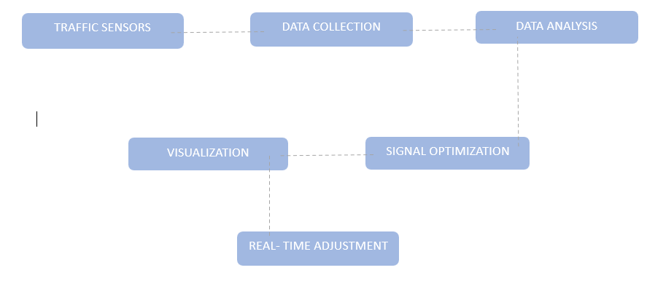

**5. User Interaction:**

**User Interface:**

A user-friendly interface is crucial for traffic managers to monitor real-time traffic conditions and manually adjust signal timings if needed. The interface should include:

**Dashboards:** Visualize traffic data, signal timings, and historical data.

**Control Panels:** Allow manual adjustments to signal timings.

**Documentation**

**Design Decisions:**

**Data Structures**: Chosen to effectively represent traffic sensor data and intersections.

**Algorithms:** Designed to dynamically optimize traffic signals based on real-time data.

**Assumptions:** Assumed high reliability of traffic sensors and accurate data.

Potential Improvements:

Incorporate machine learning for predictive traffic flow optimization.

Improve sensor reliability and data accuracy.

Integrate with other smart city infrastructure (e.g., public transport schedules).

Testing

**Test Cases:**

Normal Traffic Conditions: Ensure the system optimizes signal timings correctly.

High Traffic Density: Verify the system extends green light duration for high-density directions.

Long Vehicle Queues: Confirm the system handles long queues by adjusting signal timings.

Pedestrian Crossings: Check the system activates pedestrian signals when needed.

**java final codes:**

import java.util.HashMap;

import java.util.Map;

import java.util.Scanner;

**// Step 1: Define the IntersectionData class to hold sensor data**

class IntersectionData

{

private String intersectionID;

private String signalID;

private int queueLength;

private int averageSpeed;

public IntersectionData(String intersectionID, String signalID, int queueLength, int averageSpeed)

{

this.intersectionID = intersectionID;

this.signalID = signalID;

this.queueLength = queueLength;

this.averageSpeed = averageSpeed;

}

public String getIntersectionID()

{

return intersectionID;

}

public String getSignalID()

{

return signalID;

}

public int getQueueLength()

{

return queueLength;

}

public int getAverageSpeed()

{

return averageSpeed;

}

public String toString()

{

return "Intersection " + intersectionID + " - Signal " + signalID + " | Queue Length: " + queueLength + ", Average Speed: " + averageSpeed + " km/h";

}

}

**// Step 2: Create a service to fetch real-time sensor data**

class SensorDataService

{

private Map<String, IntersectionData> dataMap;

public SensorDataService()

{

this.dataMap = new HashMap<>();

}

public void addData(String intersectionID, IntersectionData data)

{

dataMap.put(intersectionID, data);

}

public Map<String, IntersectionData> getRealTimeData()

{

return dataMap;

}

}

**// Step 3: Create a service to control signal timings**

class SignalControlService

{

public void updateSignalTiming(String signalID, int phaseDuration) {

System.out.println("Updating signal " + signalID + " with duration: " + phaseDuration + " seconds.");

}

}

**// Step 4: Define the main TrafficSignalController class to optimize signals**

class TrafficSignalController

{

private SensorDataService sensorDataService;

private SignalControlService signalControlService;

public TrafficSignalController(SensorDataService sensorService, SignalControlService controlService) {

this.sensorDataService = sensorService;

this.signalControlService = controlService;

}

public void optimizeTrafficSignals()

{

Map<String, IntersectionData> intersections = sensorDataService.getRealTimeData();

for (IntersectionData data : intersections.values())

{

int phaseDuration = calculateOptimalPhaseDuration(data);

signalControlService.updateSignalTiming(data.getSignalID(), phaseDuration);

}

}

private int calculateOptimalPhaseDuration(IntersectionData data)

{

int queueLength = data.getQueueLength();

**// Simple formula: phase duration is queue length divided by 2, within a range**

return Math.max(30, Math.min(120, queueLength * 2));

}

public void displayTrafficConditions()

{

for (IntersectionData data : sensorDataService.getRealTimeData().values()) {

System.out.println(data.toString());

}

}

public String generateReport()

{

int totalQueueLength = 0;

int totalAverageSpeed = 0;

int count = 0;

for (IntersectionData data : sensorDataService.getRealTimeData().values())

{

totalQueueLength += data.getQueueLength();

totalAverageSpeed += data.getAverageSpeed();

count++;

}

double avgQueueLength = (double) totalQueueLength / count;

double avgSpeed = (double) totalAverageSpeed / count;

StringBuilder report = new StringBuilder();

report.append("Traffic Flow Report\n");

report.append("===================\n");

report.append("Average Queue Length: ").append(avgQueueLength).append("\n");

report.append("Average Speed: ").append(avgSpeed).append(" km/h\n");

return report.toString();

}

}

**// Main class to run the program**

public class TrafficManagementSystem

{

public static void main(String[] args)

{

**// Instantiate services**

SensorDataService sensorService = new SensorDataService();

SignalControlService controlService = new SignalControlService();

TrafficSignalController controller = new TrafficSignalController(sensorService, controlService);

**// Get user input**

Scanner scanner = new Scanner(System.in);

System.out.println("Enter the number of intersections:");

int numberOfIntersections = scanner.nextInt();

scanner.nextLine(); // Consume newline

for (int i = 0; i < numberOfIntersections; i++) {

System.out.println("Enter details for intersection " + (i + 1) + ":");

System.out.print("Intersection ID: ");

String intersectionID = scanner.nextLine();

System.out.print("Signal ID: ");

String signalID = scanner.nextLine();

System.out.print("Queue Length: ");

int queueLength = scanner.nextInt();

System.out.print("Average Speed: ");

int averageSpeed = scanner.nextInt();

scanner.nextLine(); // Consume newline

IntersectionData data = new IntersectionData(intersectionID, signalID, queueLength, averageSpeed);

sensorService.addData(intersectionID, data);

}

**// Optimize traffic signals and display conditions**

controller.optimizeTrafficSignals();

controller.displayTrafficConditions();

**// Generate and display report**

String report = controller.generateReport();

System.out.println(report);

}

}



